Operations/Work/Job Activity covered by this assessment: Cutting Machine
Required Personal Protective Equipment (PPE) :

Safety glasses must be worn at times. |   Long and loose hair must be contained.
  Appropriate footwear with substantial uppers must be worn. |   Close fitting/protective clothing to cover arms and legs must be worn.
Respiratory protection devices required. |   Oil free leather gloves and spats must be worn.

Hearing protection must be used when using this machine.

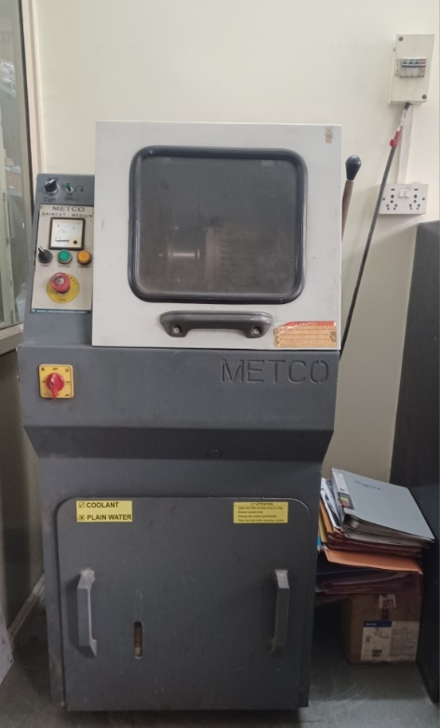
C
F
E
B
D
A
G
H
- Switch on the main supply (A)
- Switch the power in the machine (B)
- Mount the circular specimen in the vice
and align with the circular blade, close the safety door.
- Switch on the emergency button. (C)
- Press the green button and the cutting knob (D).
It glows green.
- Set the RPM knob to desired speed of cutting wheel (E)
- With the help of lever (H), slowly bring the rotating wheel
to the specimen.
- Press the coolant button (G)
- Start cutting the specimen by slowly lowering the lever.
- After cutting the specimen fully, shift the right-hand
side lever(H) to the upward position and then switch off the motor.
- Switch `OFF’ the power button on the machine (B)
- Switch `OFF’ main switch (A)

